CNP Registration for SNAP Update Notifications

To signup to receive email notifications from the CNP website (including the latest details on monthly SNAP updates to eScholar DirectMatch), please use the following instructions.

- Visit the CNP website home page at http://cnp.doe.louisiana.gov
- Click on LDOE DNS Mailing Lists (located below the log-in area)
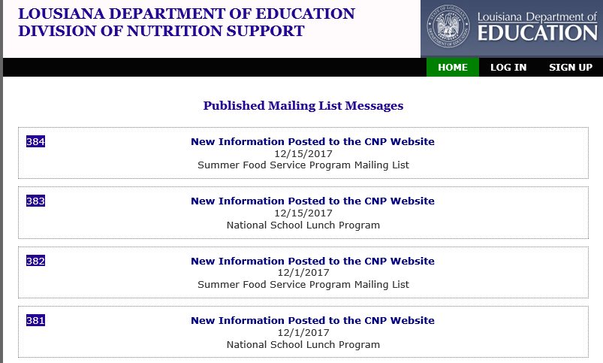

- Select “sign up” in the upper right hand corner of the screen
- Enter all required fields and hit “ok”. Required fields are the items in bold font and as follows: first name, last name, email address, password (entered twice), and code entry (as displayed on the screen). After selecting ok, a screen which requests the user’s email address (as listed on the previous screen) and a validation code will display next. Do not close out this page. Simply minimize the page, while accessing the email account on record. The user will have a new email that contains the “validation code” required to activate their account.
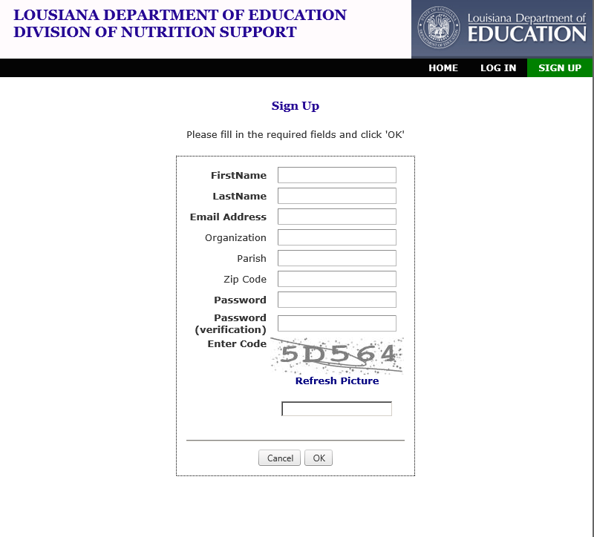

- Enter your email address and validation code (retrieved from that email account) and click on “ok”
- Once the correct email address and validation code have been entered, the next page that displays will indicate that the validation was successful

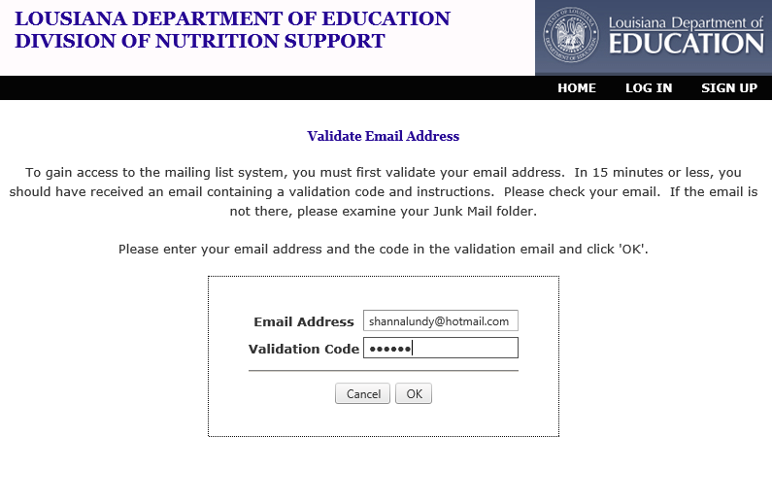
- Next, click on the Mailing Lists option that displays across the screen. A checkmark placed next to a list item will indicate that you will receive notifications pertaining to that program. Uncheck any that you do not wish to receive notifications for and “save changes”.
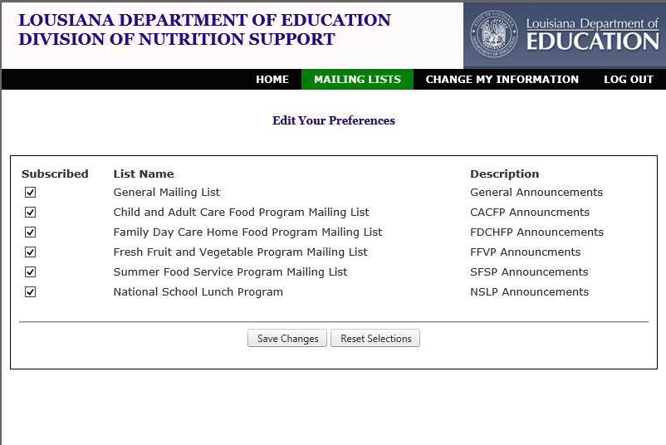

- For DC-related items, the user would only wish to keep a checkmark next to “National School Lunch Program” for instance. However, they may check as many as they are interested in receiving notifications on. Once saved, the user may log out in the upper right hand corner. The mailing list has been set up and the user can expect to begin receiving notifications from the dna@doe.la.gov CNP blast notification system.

